25 September 2025

OUSA 2026 Provisional Elections results
Total of 2469 votes cast

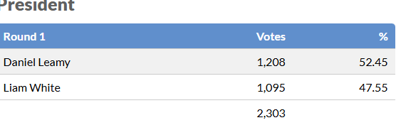

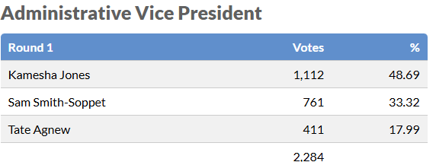

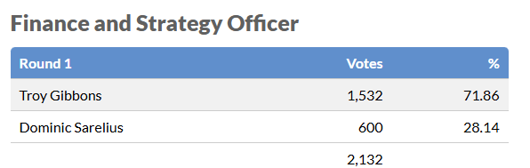

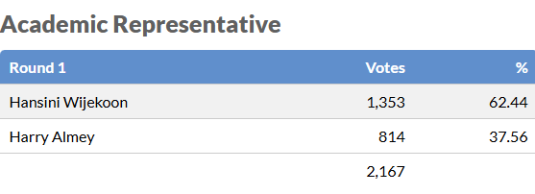

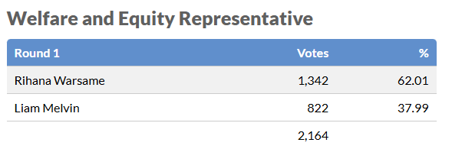

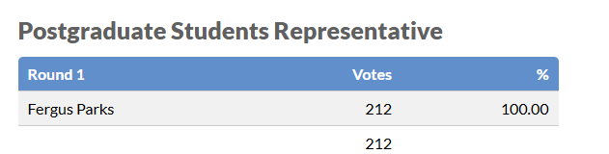

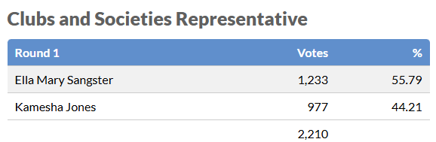

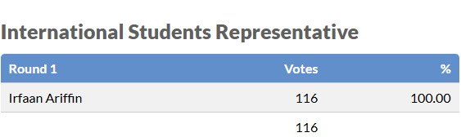

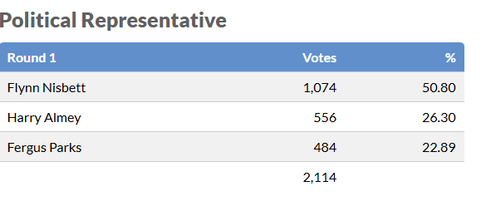

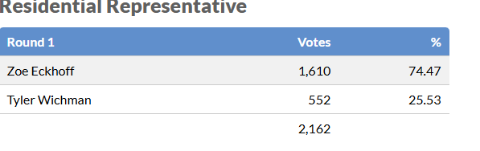

Thank you to our lovely Returning Officer, Abby Bowman

